Chapter 18, Solution 9.

Determine the Fourier transforms of the signals in Fig. 18.34.

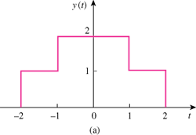

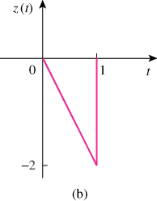

Figure 18.34
For Prob. 18.9.

Solution

- y(t) = u(t+2) – u(t-2) + 2[ u(t+1) – u(t-1) ]

(b)

